New Cardinal Newman Gaelic Football Club

in association with Gael Londain GAA

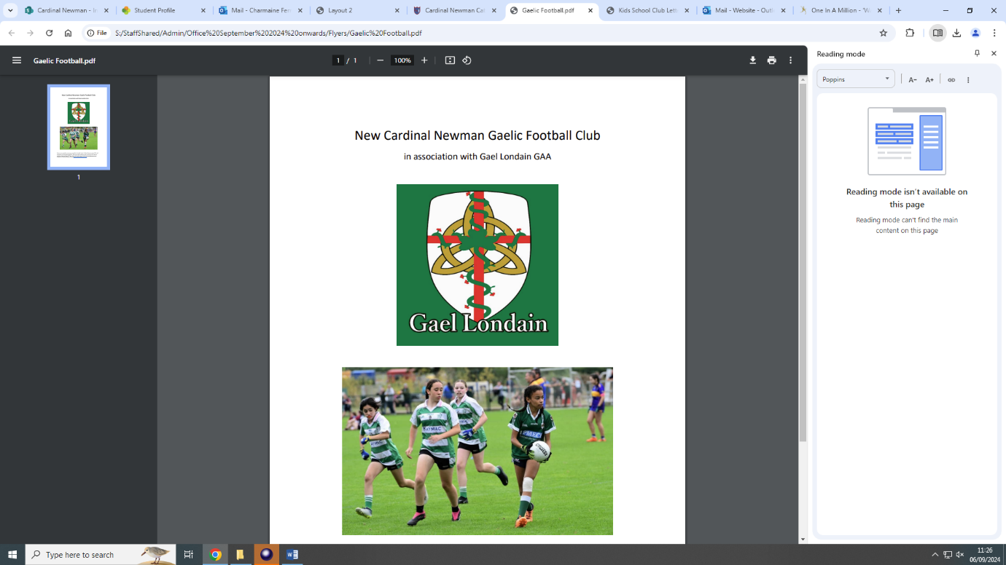

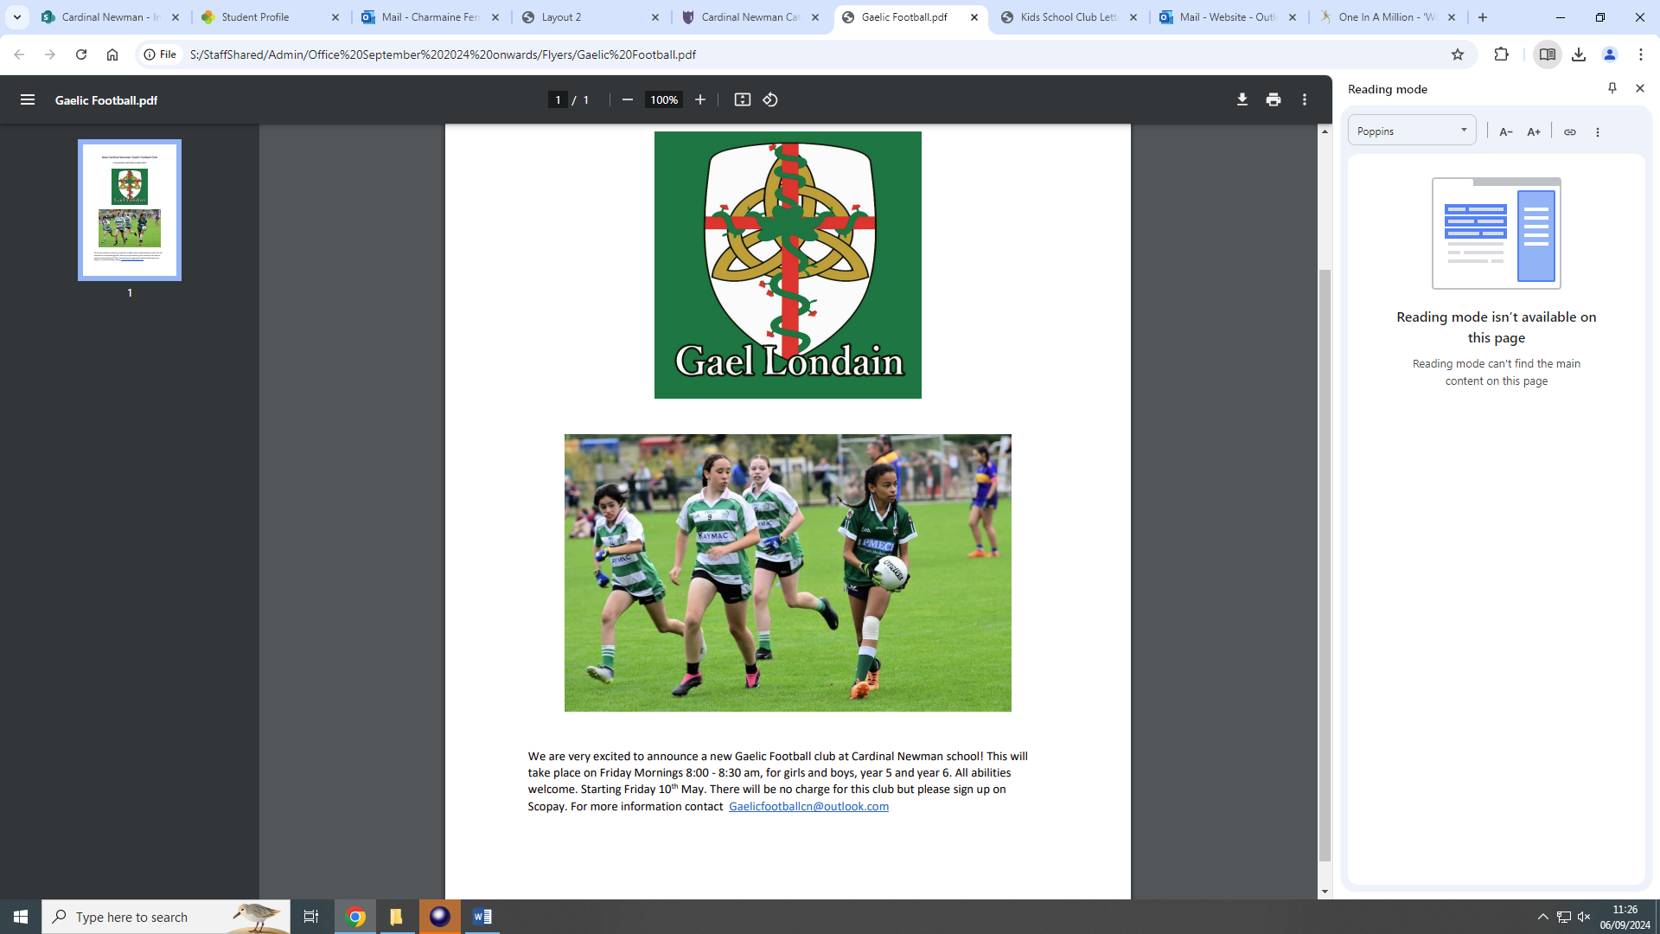

We are very excited to announce a new Gaelic Football club at Cardinal Newman School! This will take place on Friday Mornings 8:00 - 8:30 am, for girls and boys, year 5 and year 6. All abilities welcome. Starting Friday 13th September. There will be no charge for this club but please sign up on Scopay. For more information contact Gaelicfootballcn@outlook.com